

**USB**



**Name: Remax OTG Type-C USB Adapter - Silver**

**Price:** Rs. 399 ~~Rs. 700~~-43%

**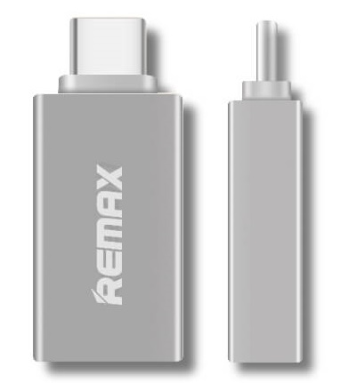  
Product details of Remax OTG Type-C USB Adapter – Silver**

* Brand: Remax
* Name: Type-C OTG
* Model: RA-OTG 1
* Color: Silver
* Package Dimension: 19 x 6.5 x 1.2cm

**Specification:**

* Brand: Remax
* Name: Type-C OTG
* Model: RA-OTG 1
* Color: Silver
* Package Dimension: 19 x 6.5 x 1.2cm

**Specifications of Remax OTG Type-C USB Adapter – Silver**

* Brand: Remax
* SKU: 134532007_PK-1294918078
* Model: USB Adapter